**LAB REPORT: 7-Segment Display**

**Introduction**

For this laboratory, I was tasked with the development of a 7-segment display, capable of being controlled via buttons/switches. The circuit uses a 7-segment display, 1x 220 Ohm resistor, a 4 pin DIP switch, and the Arduino UNO platform. It was created in TinkerCAD in order to minimize potential delays with TSA while on vacation. The display is wired to pins 7-13 on the Arduino UNO, and the DIP switch is wired to pins 2-5. The cathode of the display is wired through the 220 Ohm Resistor to ground. The 220 Ohm Resistor acts as a pullup resistor in our circuit. The schematic was created using KiKad, as EAGLE did not want to cooperate for this project.

**Implementation**

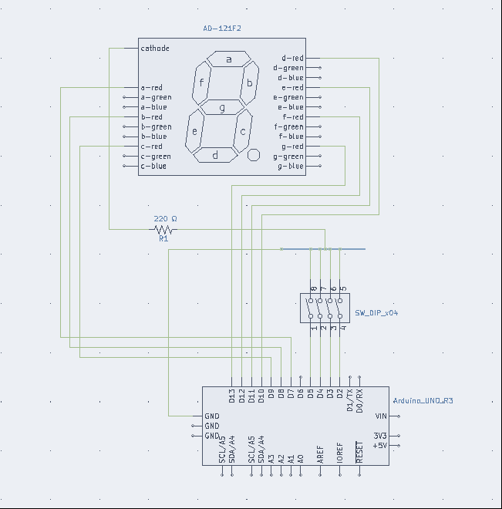The program for this project contains 233 lines of code, and was written in Visual Studio. Each pin of the display is connected to its corresponding section of the digital readout and assigned a variable. By enabling and disabling these pins, different combinations of sections can be illuminated to form single-digit numbers. Using the DIP switch, the functions for each number configuration can be triggered through the use of open and closed positions translated to binary values. The binary values are then converted to their decimal equivalents, and shown on the display. I experienced some difficulty while writing the expressions for the binary. The reverse logic and right to left switch pinout caused me to mix up the proper switch orientation on more than one occasion.

KiKad DIAGRAM

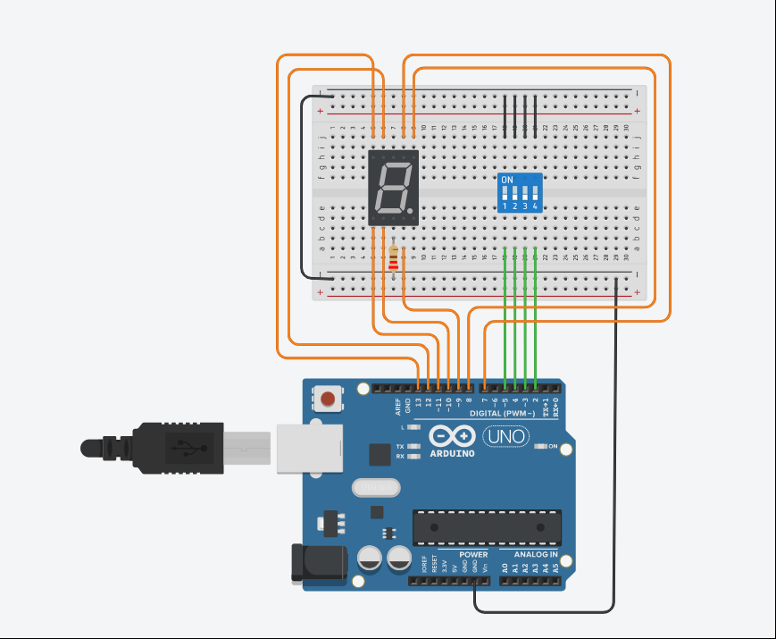

CIRCUIT

[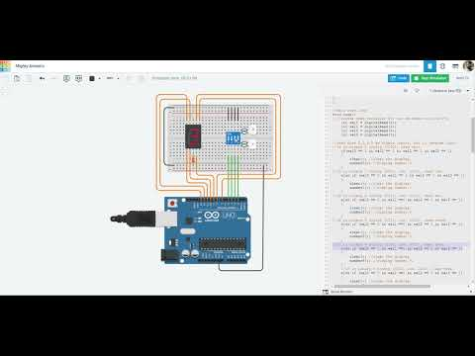](https://www.youtube.com/embed/rRPRKjDkRSg?feature=oembed)

VIDEO

//7-Segment Display

//Brandon Ackerman, RBT173

//https://youtu.be/rRPRKjDkRSg

//create variables for pins a-g on our display.

int a = 7;

int b = 8;

int c = 9;

int d = 10;

int e = 11;

int f = 12;

int g = 13;

//setup code

void setup()

{

    Serial.begin(9600); //starts the serial monitor at baud rate 9600.

for (int i = 7; i <= 13; i++) //configure "i" to inherit the values of pins 7 through 13.

{

    pinMode(i,OUTPUT); //set "i" as outputs.

}

for (int i = 2; i <= 5; i++) //configure "i" to inherit the values of pins 2 through 5.

{

    pinMode(i,INPUT_PULLUP); //set "i" as a pullup resistor input.

}

}

//main code loop

void loop()

{ //create read variables for our switches on pins 2-5.

    int val0 = digitalRead(2);

    int val1 = digitalRead(3);

    int val2 = digitalRead(4);

    int val3 = digitalRead(5);

//read pins 2,3,4,5 as binary inputs, but in reverse logic.

//if in binary 0 config (0000), read zero.

    if(val0 == 1 && val1 == 1 && val2 == 1 && val3 == 1)

    {

        clear(); //clear the display.

        number0(); //display number 0.

    }

//if in binary 1 config (0001, inv. 1110), read one.

    else if (val0 == 0 && val1 == 1 && val2 == 1 && val3 == 1)

    {

        clear(); //clear the display.

        number1(); //display number 1.

    }

//if in binary 2 config (0011, inv. 1101), read two.

    else if (val0 == 1 && val1 ==0 && val2 == 1 && val3 == 1)

    {

        clear(); //clear the display.

        number2(); //display number 2.

    }

//if in binary 3 config (0011, inv. 1100), read three.

    else if (val0 == 0 && val1 ==0 && val2 == 1 && val3 == 1)

    {

        clear(); //clear the display.

        number3(); //display number 3.

    }

//if in binary 4 config (0100, inv. 1011), read four.

    else if (val0 == 1 && val1 ==1 && val2 == 0 && val3 == 1)

    {

        clear(); //clear the display.

        number4(); //display number 4.

    }

    //if in binary 5 config (0101, inv. 1010), read five.

    else if (val0 == 0 && val1 ==1 && val2 == 0 && val3 == 1)

    {

        clear(); //clear the display.

        number5(); //display number 5.

    }

//if in binary 6 config (0110, inv. 1001), read six.

    else if (val0 == 1 && val1 ==0 && val2 ==0  && val3 ==1 )

    {

        clear(); //clear the display.

        number6(); //display number 6.

    }

//if in binary 7 config (0111, inv 1000), read seven.

    else if (val0 == 0 && val1 == 0 && val2 == 0 && val3 == 1)

    {

        clear(); //clear the display.

        number7(); //display number 7.

    }

//if in binary 8 config (1000), inv. 0111), read eight.

    else if (val0 == 1 && val1 ==1 && val2 == 1 && val3 == 0)

    {

        clear(); //clear the display.

        number8(); //display number 8.

    }

//if in binary 9 config (1001, inv. 0110), read nine.

    else if (val0 == 0 && val1 ==1 && val2 == 1 &a& val3 == 0)

    {

            clear(); //clear the display.

        number9(); //display number 9.

    }

    else

    {

        clear(); //clear the display.

      //print the line "Not in range" to the serial console.

        Serial.println("Not in range");

    }

    delay(1000); //wait one second.

}

void clear()

{

digitalWrite(a, LOW);

digitalWrite(b, LOW);

digitalWrite(c, LOW);

digitalWrite(d, LOW);

digitalWrite(e, LOW);

digitalWrite(f, LOW);

digitalWrite(g, LOW);

Serial.println("clear");

}

void number0()

{

    digitalWrite(a, HIGH);

    digitalWrite(b, HIGH);

    digitalWrite(c, HIGH);

    digitalWrite(d, HIGH);

    digitalWrite(e, HIGH);

    digitalWrite(f, HIGH);

    digitalWrite(g, LOW);

    Serial.println("0");

}

void number1()

{

   // digitalWrite(a, LOW);

    digitalWrite(b, HIGH);

    digitalWrite(c, HIGH);

   // digitalWrite(d, LOW);

   // digitalWrite(e, LOW);

    //digitalWrite(f, LOW);

    //digitalWrite(g, LOW);

    Serial.println("1");

}

void number2()

{

    digitalWrite(a, HIGH);

    digitalWrite(b, HIGH);

    //digitalWrite(c, LOW);

    digitalWrite(d, HIGH);

    digitalWrite(e, HIGH);

    //digitalWrite(f, LOW);

    digitalWrite(g, HIGH);

    Serial.println("2");

}

void number3()

{

    digitalWrite(a, HIGH);

    digitalWrite(b, HIGH);

    digitalWrite(c, HIGH);

    digitalWrite(d, HIGH);

    //digitalWrite(e, LOW);

    //digitalWrite(f, LOW);

    digitalWrite(g, HIGH);

    Serial.println("3");

}

void number4()

{

    //digitalWrite(a, LOW);

    digitalWrite(b, HIGH);

    digitalWrite(c, HIGH);

    //digitalWrite(d, LOW);

    //digitalWrite(e, LOW);

    digitalWrite(f, HIGH);

    digitalWrite(g, HIGH);

    Serial.println("4");

}

void number5()

{

    digitalWrite(a, HIGH);

    //digitalWrite(b, LOW);

    digitalWrite(c, HIGH);

    digitalWrite(d, HIGH);

   // digitalWrite(e, LOW);

    digitalWrite(f, HIGH);

    digitalWrite(g, HIGH);

    Serial.println("5");

}

void number6()

{

    digitalWrite(a, HIGH);

    //digitalWrite(b, LOW);

    digitalWrite(c, HIGH);

    digitalWrite(d, HIGH);

    digitalWrite(e, HIGH);

    digitalWrite(f, HIGH);

    digitalWrite(g, HIGH);

    Serial.println("6");

}

void number7()

{

    digitalWrite(a, HIGH);

    digitalWrite(b, HIGH);

    digitalWrite(c, HIGH);

   // digitalWrite(d, LOW);

    //digitalWrite(e, LOW);

    //digitalWrite(f, LOW);

   // digitalWrite(g, LOW);

    Serial.println("7");

}

void number8()

{

    digitalWrite(a, HIGH);

    digitalWrite(b, HIGH);

    digitalWrite(c, HIGH);

    digitalWrite(d, HIGH);

    digitalWrite(e, HIGH);

    digitalWrite(f, HIGH);

    digitalWrite(g, HIGH);

    Serial.println("8");

}

void number9()

{

    digitalWrite(a, HIGH);

    digitalWrite(b, HIGH);

    digitalWrite(c, HIGH);

    digitalWrite(d, HIGH);

    //digitalWrite(e, LOW);

    digitalWrite(f, HIGH);

    digitalWrite(g, HIGH);

    Serial.println("9");

}